**Code Enhancement Exercise**

* **Day 1 – Node changes**

1. Add default route to node.js app inside app.js file
2. add a Get method - /api/hello

e.g., http://localhost:<port>/api/hello

1. add a Post method - /api/worldpost

e.g., http://localhost:<port>/api/worldpost

* **Day 2 – React Changes**

1. Add a text box and submit button in app.js file
2. Make some CSS/stylesheet changes like the size of logo, colour of text and link etc.

* **Day 3 & 4**

1. Configure Get method in React app
2. Configure Post method in the React App.
3. Make a Get Api call to display hardcoded text, defined in the node app.
4. Make a Post Api call to post the text from Textfield.
5. Response will be displayed on the screen.

*Refer screen attached below*

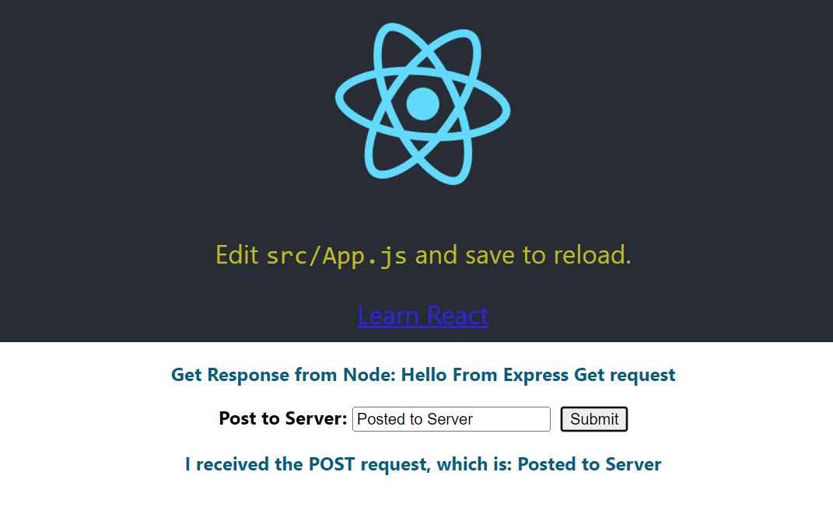

* **Day** 5 – **Showcase**

**Reference:** <https://www.freecodecamp.org/news/how-to-make-create-react-app-work-with-a-node-backend-api-7c5c48acb1b0/>